***1.INTRODUCTION***

***1.1 Purpose***

***This document specifies the software requirements for PawPulse, an innovative animal health monitoring application. The purpose of PawPulse is to provide a comprehensive platform for pet owners and veterinary professionals to track, monitor, and maintain the health and well-being of pets. The scope of this document encompasses the core functionalities of the application, including health tracking, symptom checking, veterinary consultation, and personalized recommendations. This SRS covers the initial release of the application for both iOS and Android platforms.***

***2. Document Conventions***

***Text Styles:***

***Bold: Represents section headers or important terms.***

***Italicized: Represents references or placeholders.***

***Monospace: Represents code snippets or user interface elements.***

***Priority Levels:***

***High: Critical for the release.***

***Medium: Important but can be deferred.***

***Low: Enhancements or optional features.***

***3. Intended Audience and Reading Suggestions***

***This document is intended for the following stakeholders:***

***Developers: For implementation of specified features.***

***Project Managers: For tracking progress and understanding scope.***

***Marketing Staff: To understand the product’s key functionalities.***

***Users/Testers: For validation of functionalities and user interface.***

***Documentation Writers: For creating user guides and manuals.***

***Reading Order Suggestions:***

***Overview sections (Introduction, Product Scope).***

***Functional and non-functional requirements.***

***External interface requirements for integration needs.***

***4. Product Scope***

***PawPulse is a mobile application designed to assist pet owners and veterinary professionals in tracking and improving animal health. Key features include symptom tracking, AI-driven health recommendations, personalized pet care, and real-time veterinary consultations. The platform integrates with wearables, smart devices, and e-commerce platforms to provide a holistic approach to pet health management.***

***5. References***

***User Interface Style Guide: [Internal Design Document v1.2]***

***API Documentation: [PawPulse REST API v1.0]***

***Regulatory Compliance Guidelines: GDPR, CCPA***

***Industry Standards: [Pet Healthcare Standards v2025]***

***6. Overall Description***

***6.1 Product Perspective***

***PawPulse is a standalone application designed to provide a unified platform for pet health management. It integrates seamlessly with third-party wearables and veterinary services through APIs, creating a robust ecosystem for animal healthcare. This is a new product aimed at addressing gaps in current pet care solutions.***

***6.2 Product Functions***

***Pet profile creation and management.***

***Symptom input and AI-driven analysis.***

***Personalized health and nutrition recommendations.***

***Integration with veterinary services for virtual consultations.***

***Real-time alerts and reminders for vaccinations, medications, and appointments.***

***6.3 User Classes and Characteristics***

***Pet Owners:***

***Frequent users with limited technical expertise.***

***Primary focus on health tracking and recommendations.***

***Veterinarians:***

***Users with advanced technical expertise.***

***Primary focus on consultations and data analysis.***

***Pet Care Professionals:***

***Includes groomers and trainers.***

***Focus on accessing pet history and recommendations.***

***6.4 Operating Environment***

***Platforms: iOS (13.0 and above), Android (9.0 and above).***

***Hardware: Smartphones, tablets, wearable devices (optional).***

***Cloud Services: AWS for secure storage and processing.***

***6.5 Design and Implementation Constraints***

***Compliance with GDPR and CCPA.***

***Limited support for older devices (e.g., devices with less than 2GB RAM).***

***Integration with third-party APIs for wearables.***

***6.6 User Documentation***

***User manuals (digital and printable formats).***

***Interactive tutorials within the app.***

***Online knowledge base with FAQs.***

***6.7 Assumptions and Dependencies***

***Reliable internet connectivity for full functionality.***

***Availability of third-party APIs for wearables and e-commerce.***

***Timely feedback from beta testers and veterinary consultants.***

***7. External Interface Requirements***

***7.1 User Interfaces***

***Intuitive dashboard for health tracking and symptom input.***

***Consistent navigation patterns across platforms.***

***Sample screens include:***

***Pet Profile Management***

***Health History Dashboard***

***Symptom Checker Input Form***

***7.2 Hardware Interfaces***

***Compatibility with pet wearables (e.g., smart collars).***

***Support for smart feeders and cameras.***

***7.3 Software Interfaces***

***Integration with:***

***Veterinary databases.***

***Online pet stores.***

***Third-party wearables through REST APIs.***

***7.4 Communications Interfaces***

***Supports HTTPS for secure communication.***

***Compliant with communication protocols like MQTT for IoT devices.***

***8. System Features***

***8.1 Feature 1: Symptom Checker***

***Description and Priority:***

***High priority feature enabling users to input symptoms and receive AI-driven analysis.***

***Stimulus/Response Sequences:***

***User inputs symptom details.***

***System analyzes inputs and provides potential diagnoses and urgency levels.***

***User receives recommendations for immediate actions or a vet visit.***

***Functional Requirements:***

***REQ-1: Input form for symptoms with dropdowns and free text.***

***REQ-2: AI-based analysis engine for symptom evaluation.***

***REQ-3: Display severity levels and recommendations.***

***8.2 Feature 2: Pet Health History***

***Description and Priority:***

***High priority feature for storing and reviewing past health data.***

***Stimulus/Response Sequences:***

***User accesses the pet’s profile.***

***System displays vaccination records, past diagnoses, and treatments.***

***Functional Requirements:***

***REQ-4: Store and retrieve vaccination history.***

***REQ-5: Allow export of health history as PDF.***

***9. Other Nonfunctional Requirements***

***9.1 Performance Requirements***

***Response time for symptom analysis: < 2 seconds.***

***Support for 10,000 concurrent users.***

***9.2 Safety Requirements***

***Ensure data integrity for all health records.***

***Provide disclaimers for AI-driven recommendations.***

***9.3 Security Requirements***

***Multi-factor authentication for sensitive features.***

***Data encryption for all stored and transmitted data.***

***9.4 Software Quality Attributes***

***Usability: Intuitive UI for non-technical users.***

***Reliability: 99.9% uptime guarantee.***

***Scalability: Handle increasing user base with cloud infrastructure.***

***9.5 Business Rules***

***Only certified veterinarians can provide virtual consultations.***

***Recommendations must align with regional veterinary guidelines.***

**Analysis Models**

**Use Case Diagram**

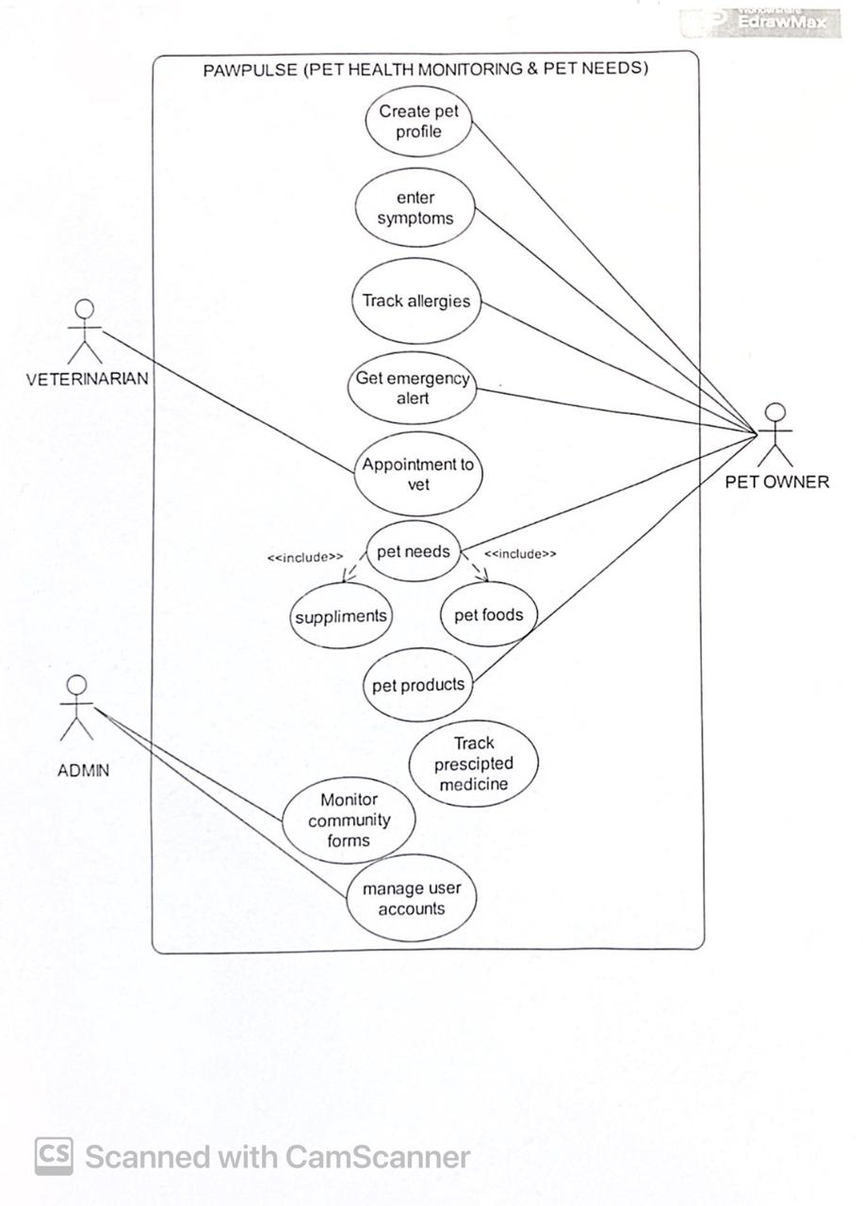

**ER Diagram**

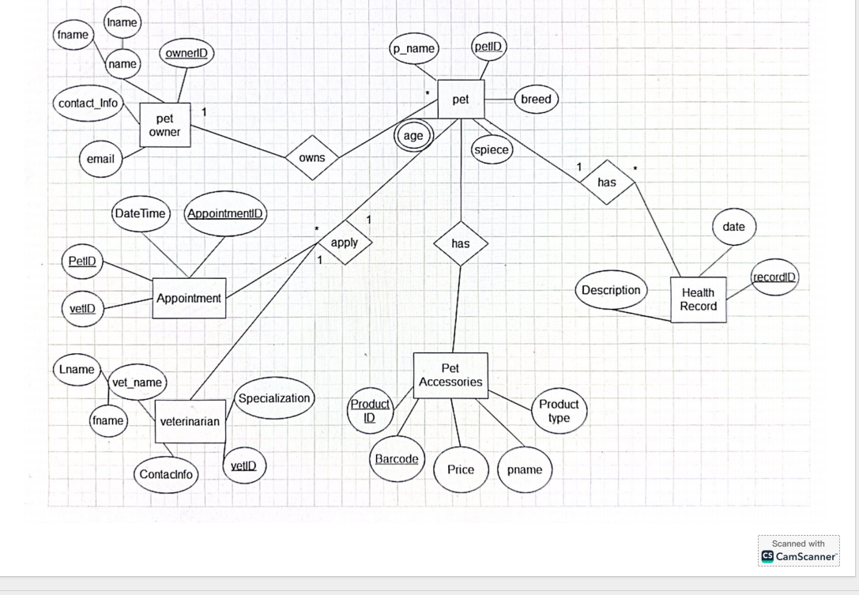

**Class Diagram**

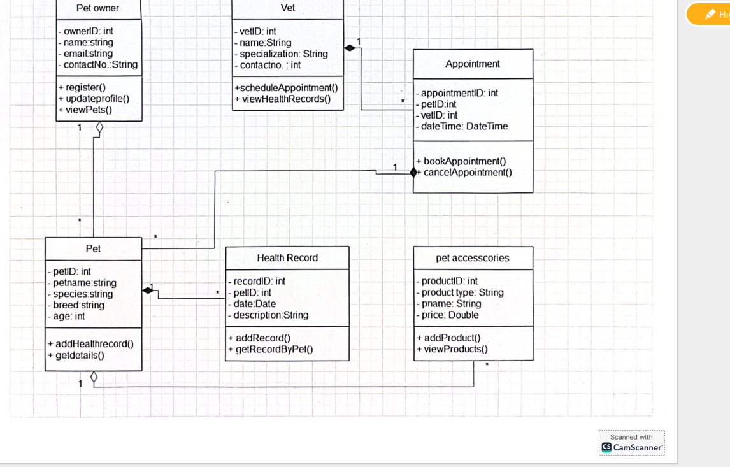

**Sequence diagram of 3 important scenarios**

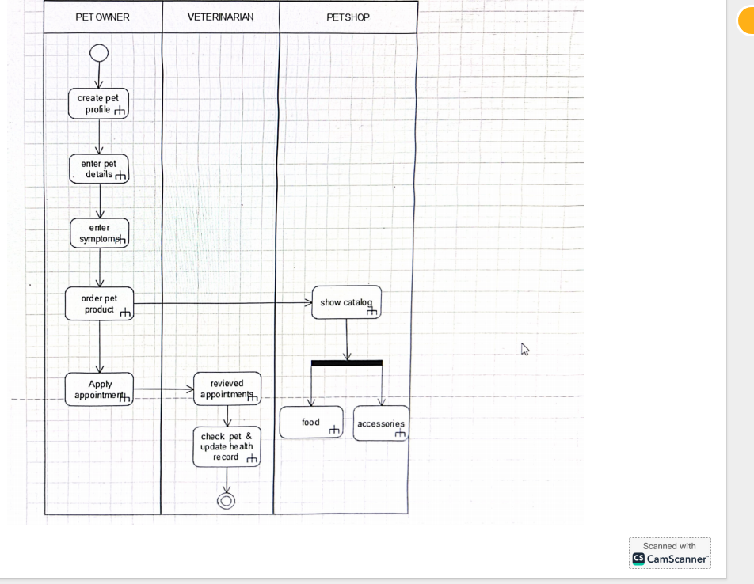

**State Diagram at least 2**

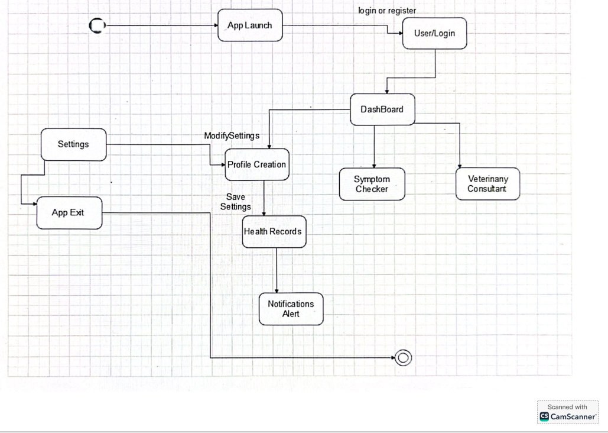

**State Diagram at least 2**

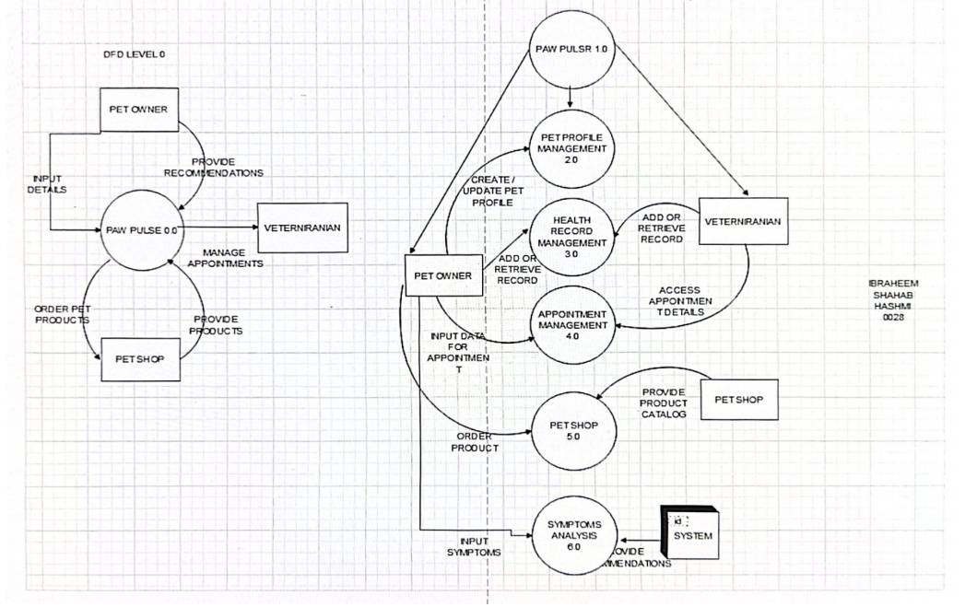

### *To Be Determined List:*

* Final selection of wearable device partners.
* Detailed UI designs for all screens.
* List of supported languages for multilingual support.